Module 8: Portfolio Project: Option #2: SAS US HHS Dataset
Christopher J. Weller
Colorado State University – Global Campus
Module 8: Portfolio Project: Option #2: SAS Code on US HHS Dataset

Even with the passage of the Affordable Care Act, US medical consumer bankruptcies are a critical issue (Himmelstein, Lawless, Thorne, Foohey, & Woolhandler, 2019). In fact, over 60% of US bankruptcies are caused by medical expenses (Amandeo, 2019). With healthcare expenses increasing faster than inflation, medical consumer bankruptcies are also expected to increase (Maddox, Bauchner, & Fontanarosa, 2019). In other countries, healthcare expenses have been shown to be higher for the elderly population (Gregersen, 2014) The purpose of this study is to determine if Total Expenses by Age Group have statistically significant different means, or if those means are not statistically different. If the means for each Age Group are similar, then US Healthcare policy to slow the rate of consumer bankruptcies should be based on other factors such as disease or disability. But, if the means for each Age Group are different, then US Healthcare policy must account for Age in addressing the increasing healthcare burden for the elderly.
Null Hypothesis:
Healthcare Expenses are not different by Age Group; thus, US policy can be the same
Expenses _{Age 0-9} = Expenses _{Age 10-19} = Expenses _{Age 20-29} = Expenses _{Age 30-39} =
Expenses _{Age 40-49} = Expenses _{Age 50-59} = Expenses _{Age 60-69} = Expenses _{Age 70-79} =
Expenses _{Age 80-89} = Expenses _{Age 90+}
Alternative Hypothesis:
Healthcare Expenses are different by Age Group; thus, US policy should be Age Based
Expenses _{Age 0-9} <> Expenses _{Age 10-19} <> Expenses _{Age 20-29} <> Expenses _{Age 30-39} <>
Expenses _{Age 40-49} <> Expenses _{Age 50-59} <> Expenses _{Age 60-69} <> Expenses _{Age 70-79} <>
Expenses _{Age 80-89} <> Expenses _{Age 90+}
Portfolio Project: Overview
The Full-Year Consolidated Data file for 2017 was downloaded from the US HHS site (US Department of Health and Human Services, 2020). Base sample SAS code to review that data file was downloaded from the Github MERP site (Mitchell, 2020). From there, SAS summary statistics, Chi Square hypothesis testing, and ANOVA hypothesis testing were generated based upon SAS Code detailed in a SAS coding book (Elliott & Woodard, 2016).
Once the SAS code was written, de-bugged, and performing properly, the code was upload to GitHub. Then, the data was reviewed for anomalies. The Chi Square results were analyzed. The correlation results were reviewed. The Age Group statistics detailed. And, finally, the ANOVA results were analyzed.
Data Review: Age Survey Information
The full-Year Consolidated Data File for 2017 had 31,880 survey results (US Department of Health and Human Services, 2020). The maximum age of the people in the survey was 85, and the minimum age was 0. Both the Median and the Mean Age for the people in the survey were 37. The 25% Q1 Age was 17, and the 75% Q3 Age was 57. All of this can be seen in Figure 1 below. In Figure 2, an Age Histogram showed a slight left skew. After reviewing the Age data, it was determined that the Age Data was able to be used without modification.
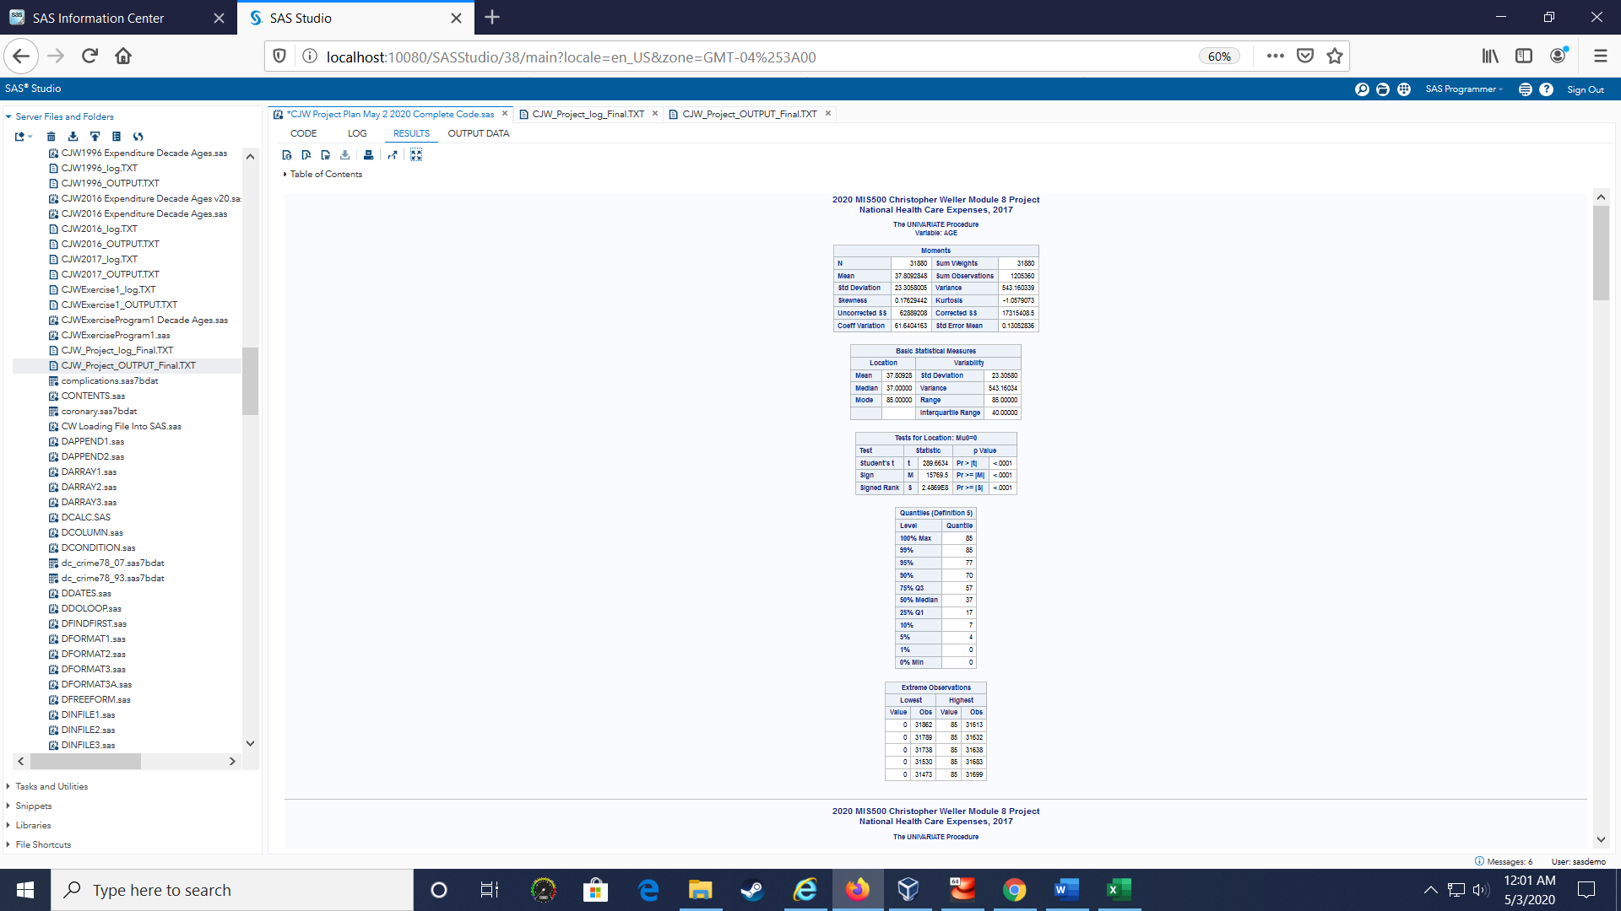
Figure 1. Output of Age Variable Statistics based upon sample SAS code from MERP.
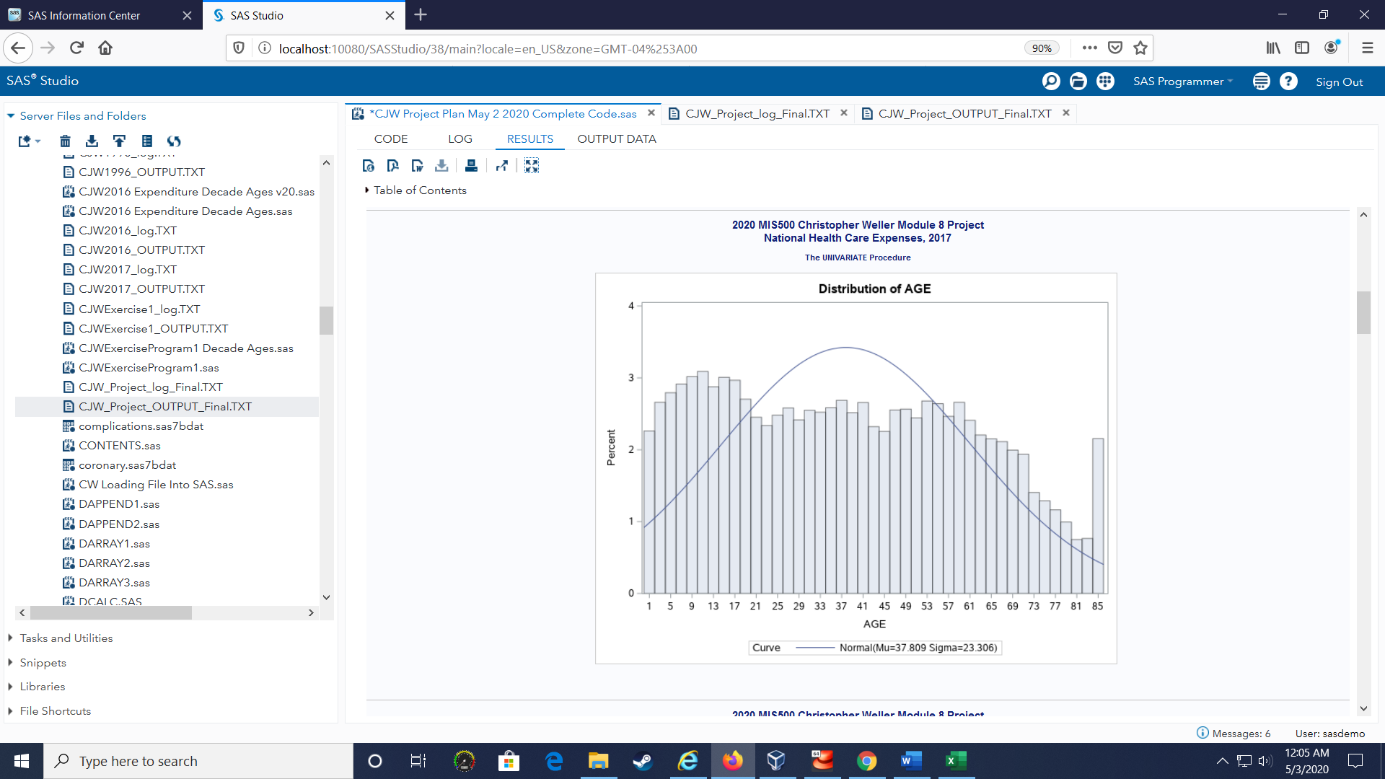 Figure 2. Age Histogram Output showing a left shew, based upon SAS Essentials book code.
Data Review: Total Expense Survey Information
Next, the number of survey respondents that had No Expenses or Any Expenses was reviewed. The results were 18% of respondents had no healthcare expenses, and 82% had healthcare expenses. In Figure 3 below, “No Expense” percent generally decreasing over Age groups, supporting the hypothesis that older people are more likely to have medical expenses.
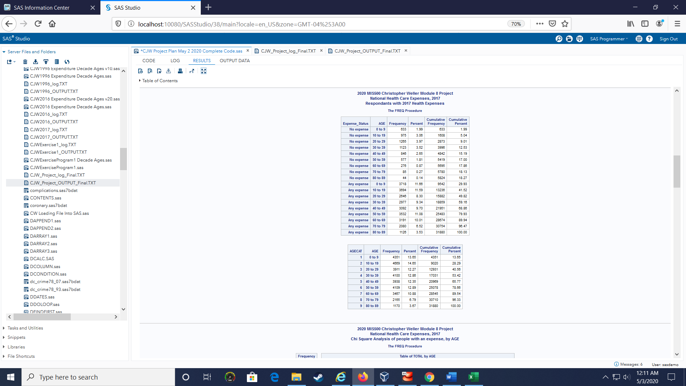
Figure 3. Output of No Expense / Any Expense review, based upon sample MERP SAS code.
Chi Square Results: Age Categories by Expense Ranges
A Chi Square Analysis was run on Age Group by Expense Range to determine if the relationship between Groups and Ranges were random, or if the differences were statistically significant. For the Expense Range of $0 to $9,999, results showed that the column percentage decreased from Age 0 to 9 of 96% to Age 80 to Age 89 of 59%. And, for the Expense Range of $50,000+, results showed that the column percentage increased from Age 0 to 9 of 0.59% to Age 80 to 89 of 6.66%. Figure 4 below shows the detailed Chi Square results, which support that Expense ranges based upon Age Groups have statistically significant differences.

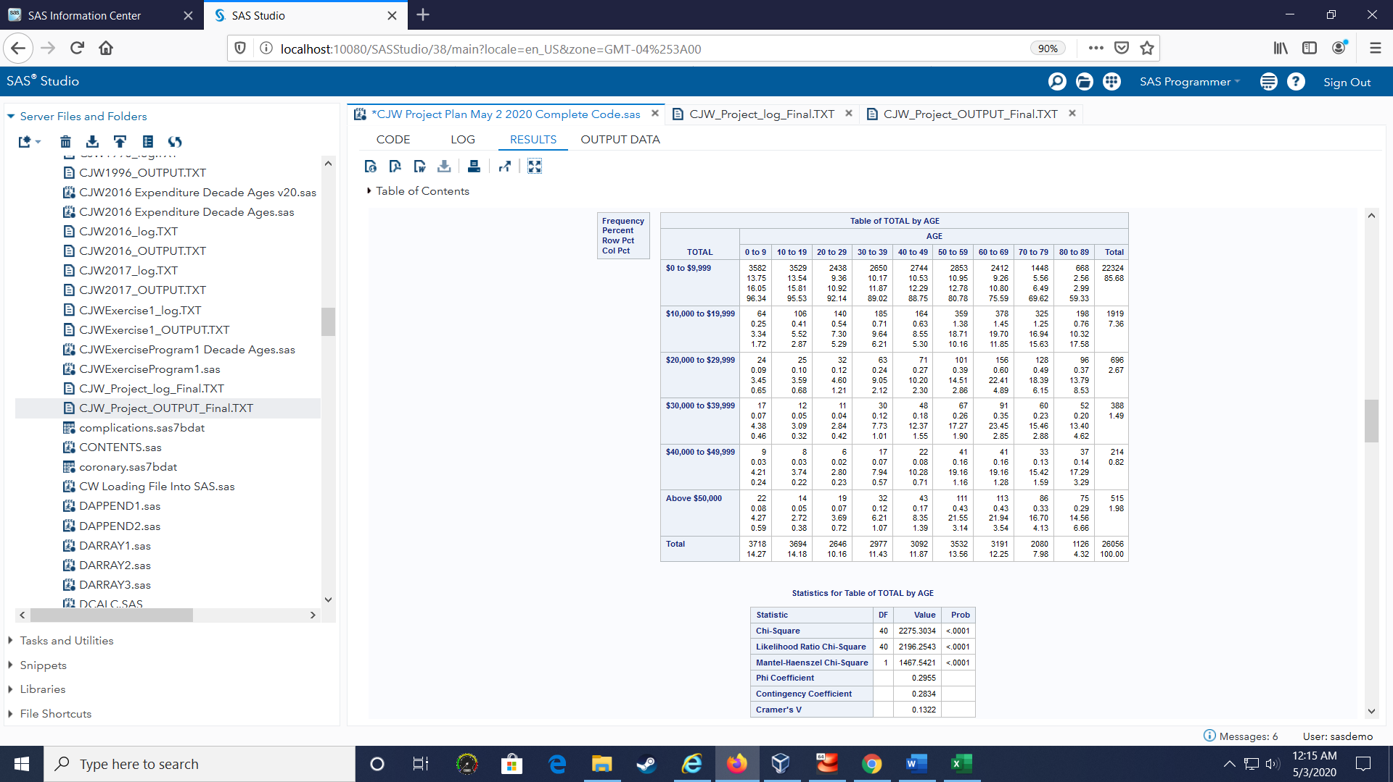
Figure 4. Chi Square analysis showing statistically significant differences based upon Age Group and Expense Groups, adapted from SAS Essentials book SAS code.
Correlation between Age and Total Expense
Next, the correlation was determined between Age and Total Expense. A statistically significant positive correlation of 20.98% was found between Age and Total Healthcare Expense. Maximum Annual Total Healthcare Expense was found to be $552,898. This positive correlation supports the hypothesis that Total Expense increases with Age. But the low correlation means that other factors beyond Age are also important. For details, please see figure 5 below.
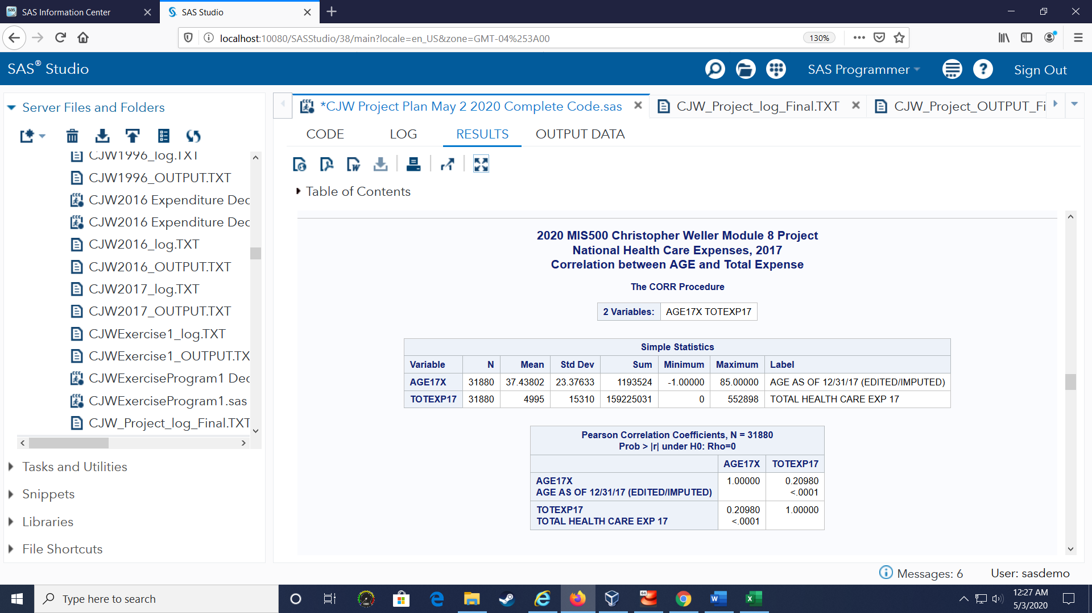
Figure 5. Correlation analysis supporting the hypothesis that Expenses increase with Age, based upon SAS Essentials book code.
2017 Age Category Statistics
276 million Americans have average healthcare expenses of $6,224, which result in $1.7 trillion in healthcare costs. The mean Healthcare Expense of Age Group 0-9 was $2,983. The mean Healthcare Expense of Age 80-89 was $15,420. So, even though Age group 80-89 is only 4% of the US population (e.g. 12 M people out of 276 M people with healthcare expenses), that Age Group incurs 11% of the Healthcare costs (e.g. $187 B out of the $1.7 T expenses). This information (detailed in Figure 6 below) supports that Age Group expenses are different, and thus Age based US Healthcare policy is needed.
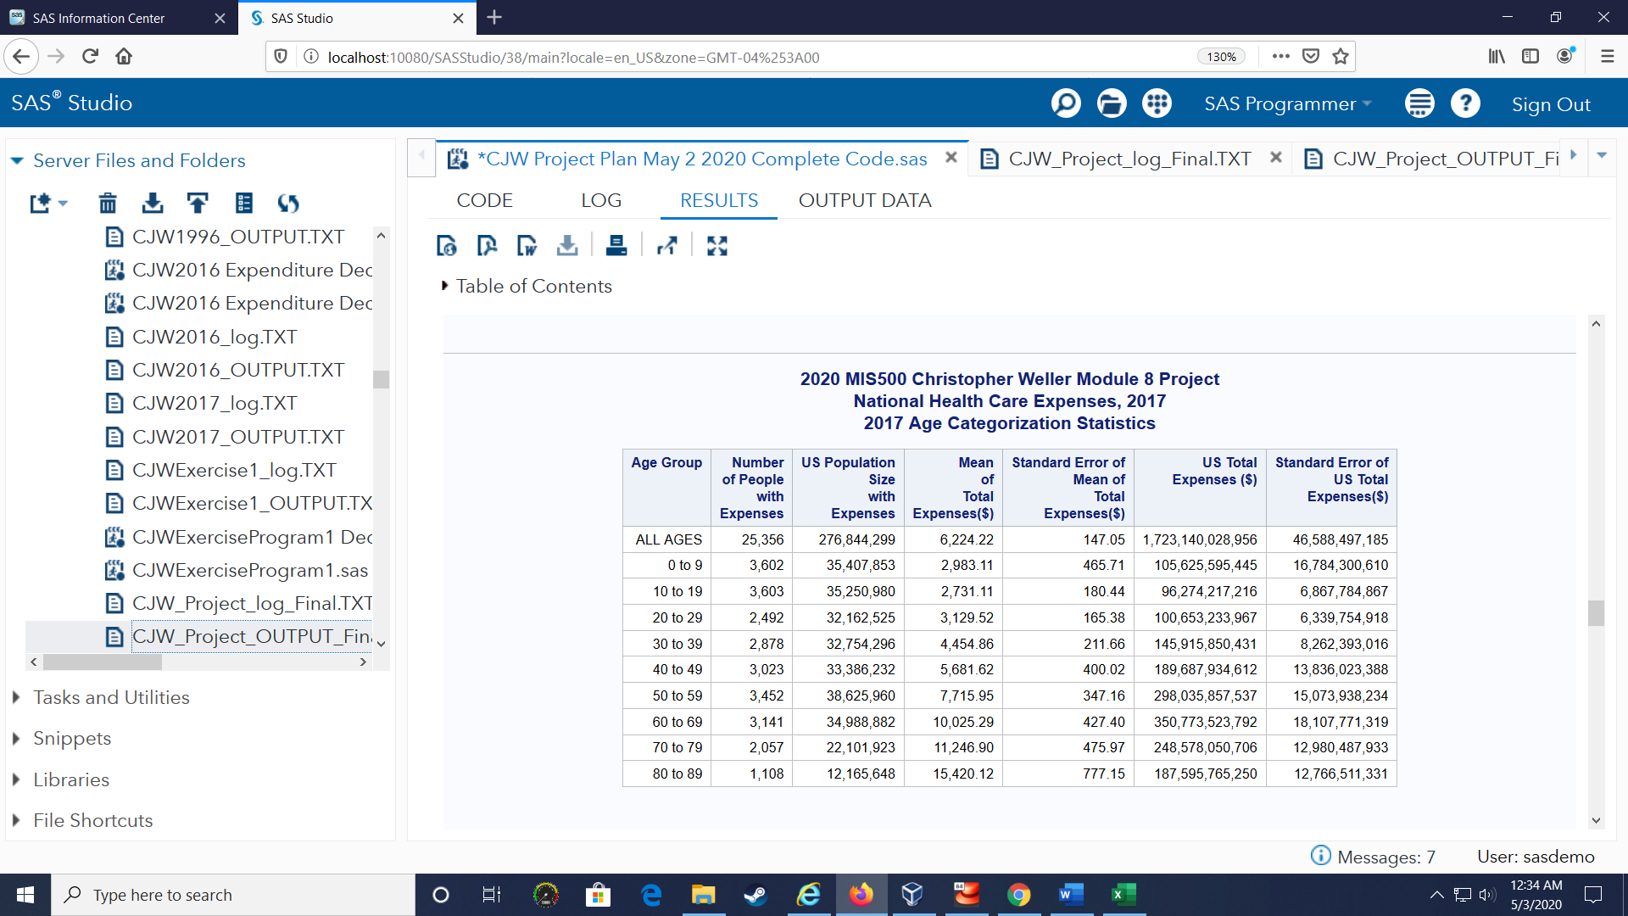
Figure 6. Output of Age Categories showing means of Age Groups are different, based upon sample MERP SAS code. The following ANOVA analysis will determine if these differences are statistically significant.
ANOVA between Age Category Results
To determine if these Age Group’s Mean Total Expenses had statistically significant differences, an ANOVA analysis was run. Surprisingly, the results of the ANOVA analysis were mixed. On one side, there were Age Groups that did not show a statistically significant difference. Specifically, Age Groups 0 to 9, 10 – 19, and 20-29 had means that were similar enough that these Age Groups may have similar Total Expense. On the other side, there were Age Groups that did show a statistically significant difference. Specifically, Age Groups 30-39, 40-49, 50-59, 60-69, 70-79, 80-89 all had means that were proven to have a statically significant difference. For these older age groups, this information supports the hypothesis that Age group’s have different Total Healthcare expenditures, and therefore supports the statement that Age Group based Healthcare policy is needed. The information also supports that Age Groups can be further consolidated to 0-29, 30-39, 40-49, 50-59, 60-69, 70-79, 80+. Please see Figure 7a, 7b, 7c for details.
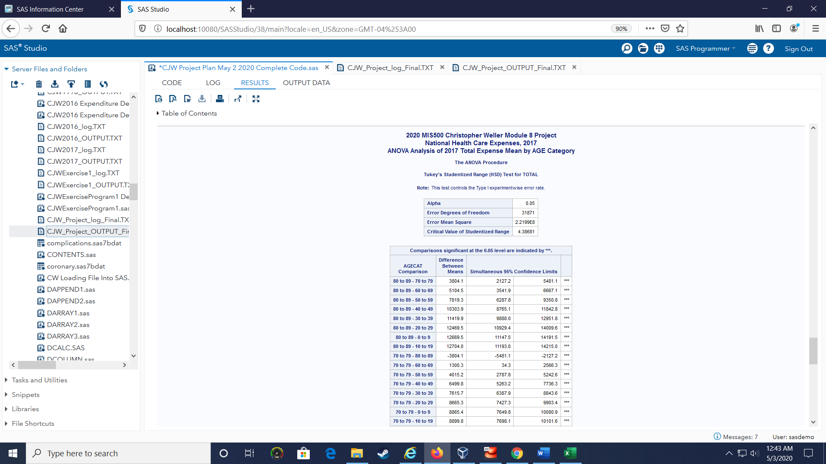
Figure 7a. First part of Output of ANOVA analysis showing statistically significant Age Category mean Total Expense differences, based upon SAS essential book code.
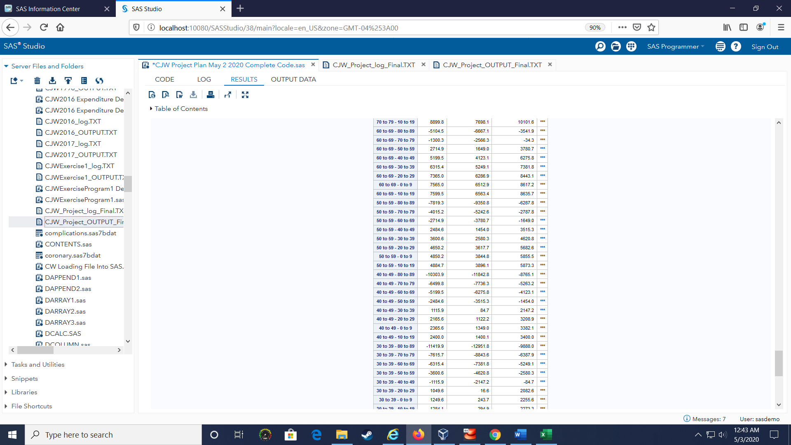
Figure 7b. Second part of Output of ANOVA analysis showing statistically significant Age Category mean Total Expense differences, based upon SAS essential book code.

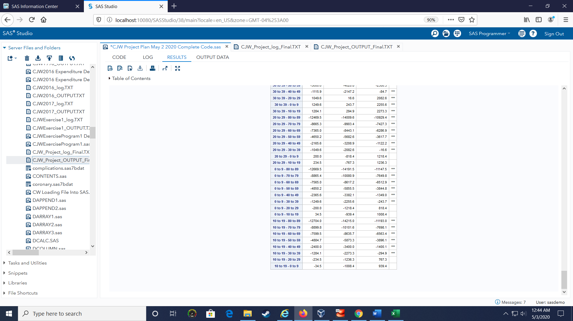
Figure 7b. Second part of Output of ANOVA analysis showing statistically significant Age Category mean Total Expense differences, based upon SAS essential book code.
Conclusion
Medical consumer bankruptcies are a major issue in the US, and these bankruptcies will likely grow in the coming years. The Chi square results from this study show that there is a statistically significant difference between Age Groups when it comes to Healthcare Expenses. The ANOVA results from this study show that there is a statistically significant difference between Age Groups when it comes to Healthcare Expenses, but only in the decade Age Groups above 30+. Thus, for the Age Groups 0 to 29, we must accept the Null Hypothesis and support the argument that healthcare policy for these ages could be uniform. But, for the decade Age Groups 30 to 89, we must reject the Null Hypothesis and support the argument that healthcare policy for these age ranges should be age range specific.
Further research is needed to determine the other factors that lead to high medical expenses besides Age, as each Age ranges had at least some representation in the over $50K annual expense range. And, further research is needed within each age group to determine which sub-category of expenses (e.g. Hospital costs, Physician costs, etc.) are driving the high expenses. To support that incremental research, the SAS code for this study has been stored as seen in Figure 8 below.
References
Amandeo, Kimberly. (2019). Medical Bankruptcy and the Economy. The Balance, Retreived from: https://www.thebalance.com/medical-bankruptcy-statistics-4154729
Elliott, A. and Woodward, W. (2016). SAS Essentials: Mastering SAS for Data Analytics. John Wiley & Sons, Inc., Hoboken, NJ.
Gregersen F. (2014). The Impact of Ageing on Health Care Expenditures: A Study of
Steepening. The European Journal of Health Economics: HEPAC: Health Economics in
Prevention and Care, 15(9), 979–989. https://doi.org/10.1007/s10198-013-0541-9
Himmelstein, D., Lawless, R., Thorne, D, Foohey, P. & Woolhandler, S. (2019).
Medical Bankruptcy: Still Common Despite the Affordable Care Act. American Journal
of Public Health 109, 431 to 433, https://doi.org/10.2105/AJPH.2018.304901
Maddox, J., Bauchner, H., & Fontanarosa, P. (2019). US Health Policy – 2020 and Beyond:
Introducing a new JAMA Series. JAMA, 2019, 321(17):1670-1672.
doi: 10.1001/jama.2019.3451
Mitchell, E. (2020) HHS-AHRQ/MEPS: Example Code for Loading and Analyzing Data from
AHRQ’s Medical Expenditure Panel Survey (MEPS). Retrieved from Gitbhub:
https://github.com/HHS-AHRQ/MEPS
SAS® University Edition. (2018). Free Software to Expand or Advance Your Career with High-Demand Analytical Skills. Retrieved from SAS: https://www.sas.com/en_us/home.html
US Department of Health and Human Services. (2020). Medical Expenditure Panel Survey (MEPS). Retrieved from Agency for Healthcare Research and Quality (AHRQ): https://meps.ahrq.gov/mepsweb/

